

***Front-End Essentials***

**Lab Guides**

|  |  |
| --- | --- |
| Document Code | 25e-BM/HR/HDCV/FSOFT |
| Version | 1.1 |
| Effective Date | 20/11/2012 |

**Hanoi, 04/2019**

RECORD OF CHANGES

|  |  |  |  |  |  |
| --- | --- | --- | --- | --- | --- |
| No | Effective Date | Change Description | Reason | Reviewer | Approver |
|  | 25/Jun/2018 | Create a new Lab | Create new | DieuNT1 | VinhNV |
|  | 01/May/2019 | Update Fsoft Template | Update | DieuNT1 | VinhNV |
|  |  |  |  |  |  |
|  |  |  |  |  |  |
|  |  |  |  |  |  |
|  |  |  |  |  |  |
|  |  |  |  |  |  |
|  |  |  |  |  |  |
|  |  |  |  |  |  |
|  |  |  |  |  |  |

Contents

Unit 4 – jQuery and AJAX 5

Objectives 5

Technical Requirements: 5

Specifications: 5

Guidelines: 6

Step 1: Create project structure 6

Step 2: Create basic HTML5 documents 6

Step 3: Open Web site 11

|  |  |
| --- | --- |
|  | **CODE: FEE.M.L401 (jQuery and AJAX)**  **TYPE: Medium**  **LOC: 200**  **DURATION: 90 MINUTES** |

# Unit 4 – jQuery and AJAX

Objectives

* Understand the core concepts of Bootstrap (layout, rows, grid, flex, components: buttons, alerts, utilities)
* Able to create complex, beautiful, responsive webpage with Bootstrap

Technical Requirements:

* Must use HTML, CSS, and Bootstrap 4

Specifications:

You have to build a Employee Management Webpage using HTML, CSS and Bootstrap 4.

The app is composed of 6 sections:

1. A Header: on the left is the Brand Name, and on the right side is 4 links: Home Page, Add an Employee, List Employes, Account information. If user click on any of 4 links, the corresponding section must be shown (i.e click on Contact will show Contact section)
2. Home section: a brief overview about the web site
3. Body section: Add an Employee or List Employees
4. Footer section

See figure below to understand better the app:

* **home-page.html** Screen:

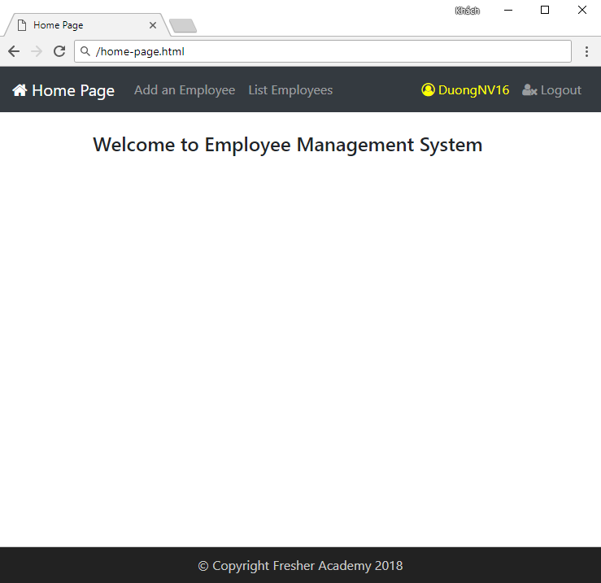

Guidelines:

Step 1: Create project structure

Create the project structure like figure below:

|  |
| --- |
|  |

Step 2: Create basic HTML5 documents

Open file index.html in VSC (Visual Studio Code), and type in html VSC will show a list of suggestions.

**Link Bootstrap 4:**

<link rel="stylesheet"

href="https://maxcdn.bootstrapcdn.com/bootstrap/4.1.0/css/bootstrap.min.css">

**Link Font Awesome:**

<link rel="stylesheet" href="https://cdnjs.cloudflare.com/ajax/libs/font-awesome/4.7.0/css/font-awesome.min.css">

<script src="https://ajax.googleapis.com/ajax/libs/jquery/3.3.1/jquery.min.js"></script>

<script src="https://cdnjs.cloudflare.com/ajax/libs/jquery-

validate/1.19.1/jquery.validate.min.js"></script>

Notice that we will use **jquery.validate.min.js** to validate **Add Employee** screen.

* **home-page.html source code:**

1. <!DOCTYPE html PUBLIC "-//W3C//DTD HTML 4.01 Transitional//EN" "http://www.w3.org/TR/html4/loose.dtd">
2. <html>
3. <head>
4. <meta http-equiv="Content-Type" content="text/html; charset=ISO-8859-1"
5. name="viewport" content="width=device-width, initial-scale=1">
6. <link rel="stylesheet"
7. href="https://maxcdn.bootstrapcdn.com/bootstrap/4.1.0/css/bootstrap.min.css">
8. <link rel="stylesheet" href="https://cdnjs.cloudflare.com/ajax/libs/
9. font-awesome/4.7.0/css/font-awesome.min.css">
10. <link rel="stylesheet" href="../resources/css/home-page.css">
11. <script
12. src="https://ajax.googleapis.com/ajax/libs/jquery/3.3.1/jquery.min.js"></script>
13. <script src="https://cdnjs.cloudflare.com/ajax/libs/jquery-
14. validate/1.19.1/jquery.validate.min.js"></script>
15. <title>Home Page</title>
16. </head>
17. <body>
18. <nav class="navbar navbar-expand-sm navbar-dark bg-dark">
19. <a class="navbar-brand" href="#">
20. <i class="fa fa-home"></i> Home Page
21. </a>
22. <div id="navbarNavDropdown" class="navbar-collapse collapse">
23. <ul class="navbar-nav mr-auto">
24. <li class="nav-item">
25. <a class="nav-link" href="#" id="addEmpLink">
26. Add new employee
27. </a>
28. </li>
29. <li class="nav-item">
30. <a class="nav-link" id="listEmpsLink" href="#">List employees
31. </a>
32. /li>
33. </ul>
34. <ul class="navbar-nav ml-auto">
35. <li class="nav-item">
36. <a class="nav-link" style="color: yellow" href="#">
37. <i class="fa fa-user-circle-o"> DuongNV16 </i>
38. </a>
39. </li>
40. <li class="nav-item">
41. <a class="nav-link" href="#">
42. <i class="fa fa-user-times"></i> Logout</a>
43. </li>
44. </ul>
45. </div>
46. </nav>
47. <div class="container">
48. <h4>Welcome to Employee Management System</h4>
49. </div>
50. <div class="row fixed-bottom" style="border-top: 1px solid #ccc;
51. background-color: #222">
52. <div class="col-md-12">
53. <p style="margin: 10px auto; text-align: center; color: #ccc">
54. &copy; Copyright Fresher Academy 2018</p>
55. </div>
56. </div>
57. <script src="../resources/js/home-page.js"></script>
58. </body>
59. </html>

Add jQuery link: script src="../resources/js/home-page.js"></script>.

* **home-page.js source code**

1. $(document).ready(function() {
2. $("#addEmpLink").click(function() {
3. $.get({
4. url: "/views/add-employee.html",
5. success: function(response) {
6. $(".container").html(response);
7. $("#employeeName").focus();
8. }
9. });
10. });
11. $("#listEmpsLink").click(function() {
12. $.get({
13. url: "/views/list-employees.html",
14. success: function(response) {
15. $(".container").html(response);
16. }
17. });
18. });
19. });

According to this design, when the user clicks "Add an Employee" or "List Employees" the web page will appropriate display.

We are using the **$.get ()** method in the jQuery library.

* **add-employee.html** Screen**:**

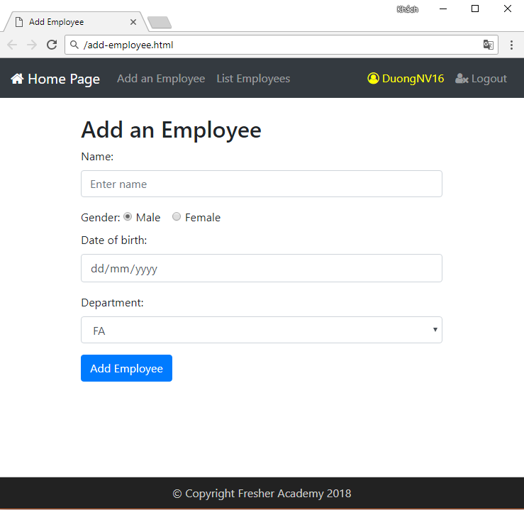

* **add-employee.html Source code:**

1. <form action="#" method="post" name="frm-addEmp">
2. <div class="row">
3. <div class="col-md-6 offset-md-3">
4. <h2>Add a Employee</h2>
5. <div class="form-group">
6. <label for="employeeName">Name:</label>
7. <input type="text" class="form-control" id="employeeName"
8. placeholder="Enter name" name="employeeName">
9. </div>
10. <label for="gender">Gender:</label>
11. <div class="form-check-inline">
12. <label class="form-check-label">
13. <input type="radio" class="form-check-input"
14. name="gender" value="1" checked>Male
15. </label>
16. </div>
17. <div class="form-check-inline">
18. <label class="form-check-label">
19. <input type="radio" class="form-check-input"
20. name="gender" value="0">Female
21. </label>
22. </div>
23. <div class="form-group">
24. <label for="dateOfBirth">Date of birth:</label>
25. <input type="date" class="form-control" id="dateOfBirth"
26. placeholder="Enter date of birth" name="dateOfBirth">
27. </div>
28. <div class="form-group">
29. <label for="dept">Department:</label>
30. <select class="form-control" id="dept"></select>
31. </div>
32. </div>
33. </div>
34. <div class="row">
35. <div class="col-md-6 offset-md-3">
36. <button type="button" id="btn-addEmp" class="btn btn-primary">
37. Add Employee
38. </button>
39. </div>
40. </div>
41. </form>
42. <script src="../resources/js/add-employee.js"></script>

**Add jQuery file:**

1. <script src="../resources/js/add-employee.js"></script>

* **add-employee.js source code:**

1. $(document).ready(function() {
2. // Create attribute maxDate to check if input date higher than current date
3. $.validator.addMethod("maxDate", function(value, element) {
4. var curDate = new Date();
5. var inputDate = new Date(value);
6. if (inputDate < curDate)
7. return true;
8. return false;
9. }, "Invalid date of birth");
10. $("#addEmpForm").validate({
11. rules: {
12. employeeName: {
13. required: true,
14. minlength: 5
15. },
16. dateOfBirth: {
17. required: true,
18. maxDate: true
19. },
20. dept: {
21. required: true
22. }
23. },
24. messages: {
25. employeeName: {
26. required: "Please enter employee name",
27. minlength: "Employee name must contain at least 5 characters"
28. },
29. dateOfBirth: {
30. required: "Please choose a date"
31. },
32. dept: {
33. required: "Please choose a deparment"
34. }
35. },
36. submitHandler: function(form) {
37. $.get({
38. url: "/views/list-employees.html",
39. success: function(response) {
40. $(".container").html(response);
41. }
42. });
43. }
44. });
45. });

The web page when the user click **Add Employee** button.

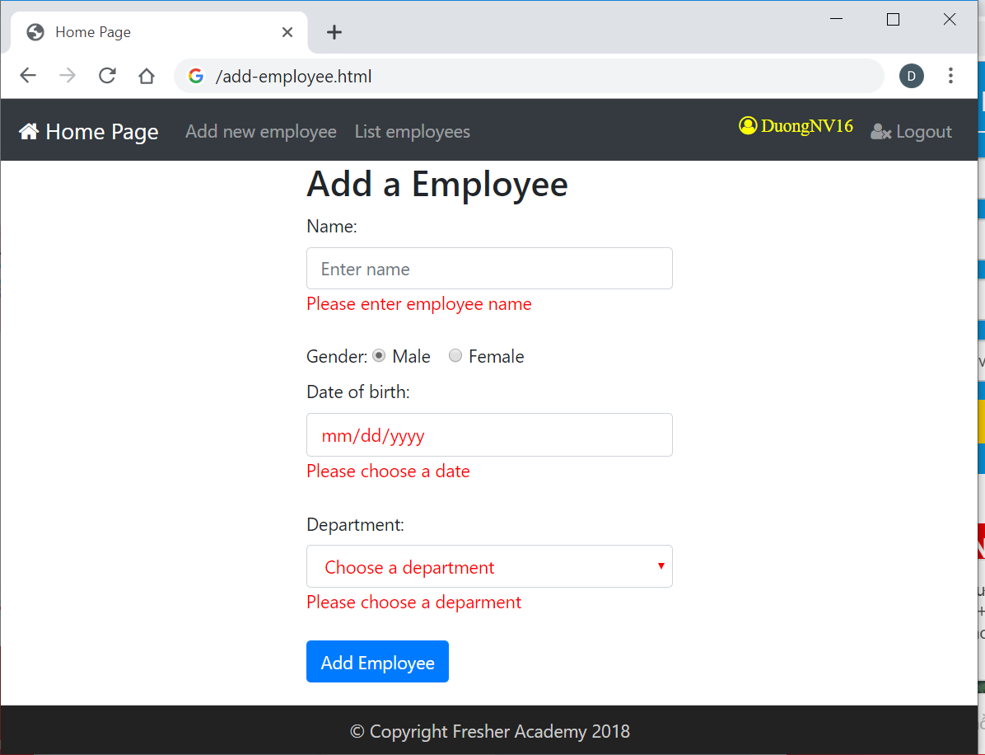

* **list-employees.html** Screen**:**

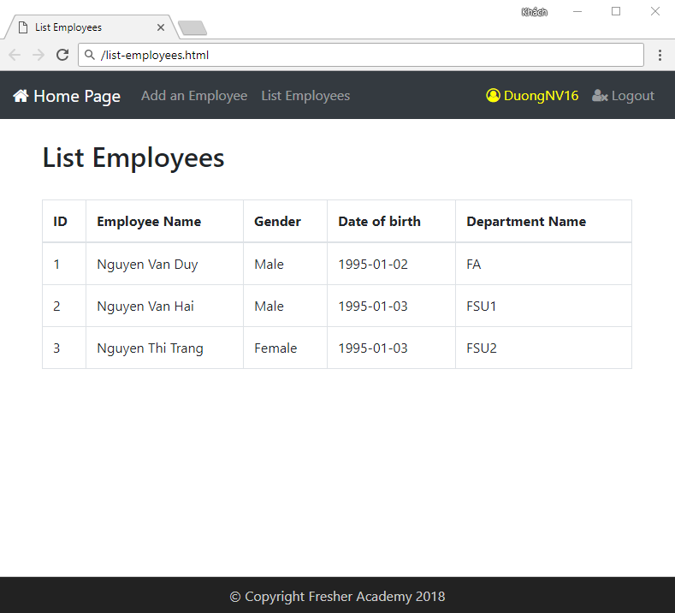

* **list-employees.html Source code:**

1. <h2>List of Employees</h2>
2. <br />
3. <table class="table table-bordered">
4. <thead>
5. <tr>
6. <th>ID</th>
7. <th>Employee Name</th>
8. <th>Gender</th>
9. <th>Date of birth</th>
10. <th>Department Name</th>
11. </tr>
12. </thead>
13. <tbody>
14. <tr>
15. <td>E101</td>
16. <td>Nguyen Van Khoa</td>
17. <td>Male</td>
18. <td>01/01/1990</td>
19. <td>Fresher Academy</td>
20. </tr>
21. </tbody>
22. </table>

Step 3: Open Web site

Right-click on index.html file and click Open with Live Server

Note: You must install Live Server extension of VSC

|  |
| --- |
|  |

**Step 14: Verify and tweak**

Open the app using Live Server, you should have the same layout like figure below:



And



The app looks pretty much like the design!

**-- THE END --**